Sets, React Form, & NULL
Working with your Trio/Buddy:
- Discuss: If you could bring one fictional character to life as a coworker, who would it be?
- Reflection: How has your confidence in your technical abilities changed through your contributions to this group?
- Explore: What are unique form validations that you have seen? Visually share an example to your peers.

Data Structures: SET
Sets are a data structure in ES6 (ES2015) that allows creating collections of unique values. The values in a set can be either simple primitives like strings or integers as well as more complex object types like object literals or arrays.

(Note: You might see definitions of sets being an object - this is object like a person, place, or thing, not object like the JS data structure with key: value pairs. In your definitions try not to use the word “object” as it can be easily confused)

Useful Set methods:
- add(value) – appends a new element with a specified value to the set. It returns the Set object, therefore, you can chain this method with another Set method.
- clear() – removes all elements from the Set object.
- delete(value) – deletes an element specified by the value.
- entries()– returns a new Iterator that contains an array of [value, value]
- forEach(callback [, thisArg]) – invokes a callback on each element of the Set with the this value sets to thisArg in each call.
- has(value) – returns true if an element with a given value is in the set, or false if it is not.

(Image from the MDN docs)

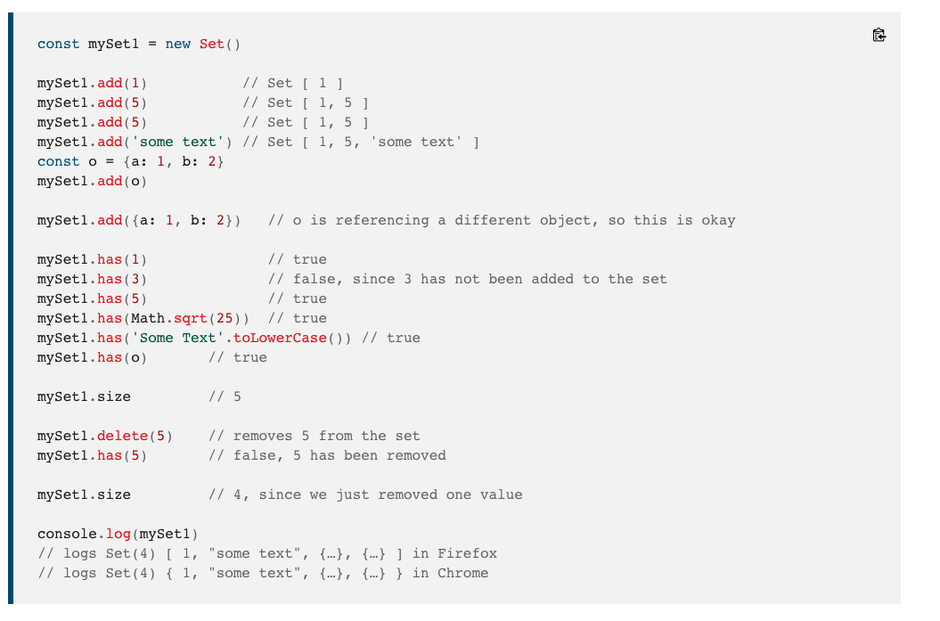

W3 CSS Topic: CSS Sidebar or vertical navigation
With side navigation, you have several options:
- Always display the navigation pane to the left of the page content
- Use a collapsible, "fully automatic" responsive side navigation
- Open navigation pane over the left part of the page content
- Open navigation pane over all of the page content
- Slide the page content to the right when opening the navigation panel
- Display the navigation pane on the right side instead of the left side

SQL Topic: NULL Values
Learn about the syntaxis and correct uses of the IS NULL and IS NOT NULL operators.

End-of-day questions:

JS Sets
- What is a set?
- What built in set methods do you know
- What types of data can I hold in a set?

CSS - sidebar navigation

React & React Forms
- What do you know about creating forms in React?
- Setting the state and managing the change in the State (using setState)
- Handling changes in the input (hint: callback functions!)
- Showing a successful message
- Managing errors

SQL - IS NULL vs NULL values

EOD Quiz: NULL, useState, Event Handler, onChange, & Form Values

